British Fencing World Class Programme (WCP)

Talent Assessment

27-28 June 2015

The World Class Programme (WCP) is inviting applications to attend the next assessment to join the Talent Programmes on the 27th / 28th June 2015.

Fencers will only be assessed on one of the days and this will be confirmed once all applications have been received and assessed.

The assessments will take place at the WCP Elite Training Centre at the Leon Paul centre in Hendon, London NW9 6AQ www.leonpaulfencingcentre.com

Application Criteria?
Any athlete who is under 20 on 1st January 2015 (born between 1995 and 2003) is able to apply to be part of one of these programmes.

Fencers in the current top five of the U17 rankings or top three of the U20 rankings are guaranteed to be invited to one of the assessment days should they make an application and can make the nominated day of assessment.

Not all applicants will be invited to attend; assessment will be limited to 24 athletes in each of the three weapons. Fencers who have already done an assessment and were not invited to join one of the programmes are welcome to reapply.

We would expect that fencers wishing to be part of one of these Programmes would be already training several times per week and have the full support of their personal coach in making their application.

All personal coaches are welcome and encouraged to attend the assessment with their fencer.

What do I need to do to apply?
Please complete the form below in full & return it to Neil Brown neil.brown@britishfencing.com. Completed application forms should be returned as soon as possible, but no later than 5.30pm on Friday 5th June 2015. Any applications received after this time will not be considered for these assessment days.

We will provide you with further information once we have confirmed your selection for attendance at one of the selection days.

The British Fencing WCP Performance Programmes

The aim of the two talent programmes is to deliver a structured development programme to identified young fencers, providing a high performance experience and support to promote success on the world stage.
Athletes receive a combination of programme support depending on their identified level including:-

- Formal induction programme
- Individual meeting between the Talent Lead Coach, fencer and personal coach identifying the key areas of growth that will provide the backbone of their development plan
- Detailed development, training and competition plan
- Additional coaching expertise in line with the athlete’s development, training and competition plan
- Centralised training sessions throughout the year
- Education and practical tools that cover the key facets that make up a world-class fencer
- Regular development and performance reviews with athlete, personal coach and the Talent coach
- Access to the WCP training venue, facilities and resources

Programme levels
Podium
Podium level places are awarded by UK Sport where it can be demonstrated through detailed objective analysis of performances that an athlete / team will win a medal in Rio.
Podium Potential
UK Sport awards Podium Potential places for the current cycle where it can be demonstrated, through detailed objective analysis of performances and potential ability, that an athlete / team will qualify for Rio and deliver a medal in 2020.
Talent Programme
This programme represents the second stage of the performance pathway for talented fencers. Fencers on the Talent Programme have been confirmed either through a direct assessment process or via the TIC programme as having the key attributes that, if developed further, could lead to becoming a world-class fencer. This programme underpins the World Class Podium Potential Programme and seeks to add value to an athlete’s development because they have demonstrated significant commitment and performance potential.
Talent Identification and Confirmation Programme (TIC)
This programme represents the first stage of the performance pathway and is an extended assessment programme whereby an athlete’s talent characteristics are carefully verified, prior to stepping up onto the Talent Programme or returning back to a club environment. This includes the examination of a fencer’s coachability, responsiveness to training and adaptation to a high performance environment. The TIC programme also allows athletes to make an informed judgment about the Olympic journey ahead and whether this is a route they want to commit to.
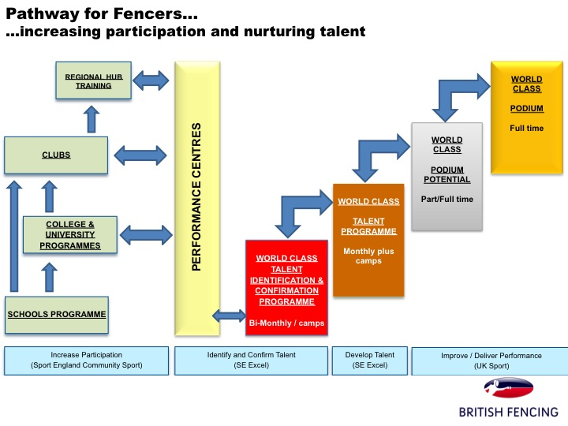

TALENT ASSESSMENT - APPLICATION FORM
PERSONAL DETAILS
Surname: | First Name:
Address:  Postcode: | Home Telephone:  Mobile Telephone Number:
 | Email Address(s):
Date of Birth:
PARENT’S DETAILS (IF AGED U18)
Surname: | First Name:
Address:  Postcode: | Home Telephone:  Work Telephone:  Mobile Telephone Number:  Email Address(s):

Main fencing club: | Main coach:
Other fencing club(s): | Other coach(es):

EDUCATION
Which educational establishment are you attending in 2015-16: | Name:  Address:
Further details about your education which may be useful. Please provide information you feel relevant to your participation in the Talent programmes

FENCING
What is your current British National ranking | Junior ranking:  Cadet ranking:
When did you first start fencing (age and date)?
When did you first compete?
When did you first start training seriously?
Describe the training you normally do in term-time. | Months per year  Days per week  Hours per week  Description
What have been your best 5 competition results?
Any further information about your fencing?
Have you competed at any other sports? If so please give details about your results.

AMBITION and PERSONAL STATEMENT
What are your ambitions for your fencing career?

Please state what you have done to support your ambitions so far.

Personal statement:-
Please state what future training and commitments you are planning to support your ambitions in the sport, include details of education, career plans, etc. This should be no more than 300 words.

PERSONAL COACH SUPPORTING STATEMENT
Name:
What do you believe are the strengths of this fencer?

Where do you believe there are areas for growth?

Please comment on how you believe this fencer would benefit from being on one of the Programmes:-

I will attend the assessment day:-
YES
NO

I am available: Saturday 27th June ☐ Sunday 28th June ☐ Either day ☐

Signed (parent or guardian if U18): _________________

Date: ________________

Name: ________________________________________________

I accept that by attending the assessment, I am fit to participate and understand that all sporting activities carry the risk of injury. I agree to inform the British Fencing WCP of any existing medical condition or injury which may affect my ability to take part.

British Fencing is committed to providing equal opportunities for all and is committed to following best practice in the welfare of young people and vulnerable adults. For further information please consult: www.britishfencing.com
If you would like this form in an alternative format please contact Neil Brown to discuss your requirements.

Please return to Neil Brown, neil.brown@britishfencing.com or by post to:-
Neil Brown, British Fencing, 1 Baron's Gate, 33-35 Rothschild Road, London, W4 5HT
Please do this as soon as possible but at the latest to arrive by 5.30pm on Friday 5th June 2015

